Dody Rachmat Wicaksono  
dodyrw@gmail.com, 2 Des 2010

[www.nicecoder.com](http://www.nicecoder.com)

This document is intended to be used for Indexu Deluxe 2.4

How to use ebanner 2.0 plugin

# Installation

Download ebanner plugin from indexutemplates.com. This file called ebanner.zip. Unzip it then upload the /ebanner folder to your server inside /plugin folder.

The next step is go to indexu admin panel > **Plugins**. Then click install button for ebanner plugin.

Now you should have a new sidebar menu for banner management like below:

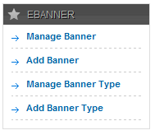

# Add a new banner type

Before you can put any banners, you need to create a new banner type. Click **Add Banner Type**. Here you need to set the banner configuration. All fields are requiered.

* Name of banner type
* Maximum Width (Pixel)
* Maximum Height (Pixel)
* Price Per Year (USD)
* Price CPM (USD)
* Default Banner

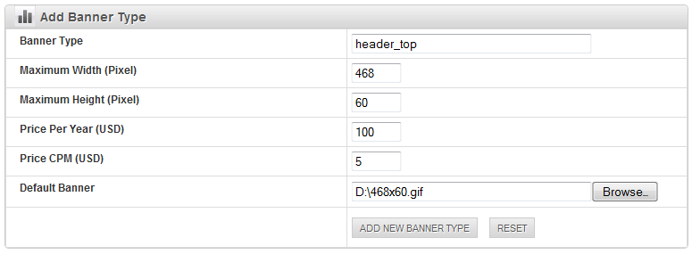

To make it easier to remember, use the banner location as banner type name.

After you created a new banner type, there will be a banner submission form will be available in user control panel too (/plugin_action.php?f=PL_eBannerAddBanner). Here is the screenshot how it look in user control panel (/cp).

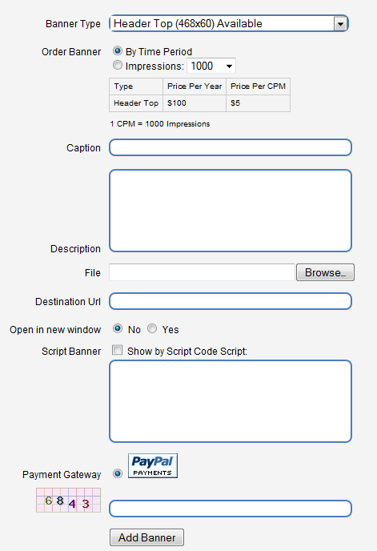

The appearance may different based on the template you use. To customize how it look, you need to change the plugin template located in /plugin/ebanner/template/add_banner.html

You can also change other ebanner template files if necessary.

# Add a new banner

In this tutorial I will add a new banner using admin panel. So it will be an instant approval. Click **Add Banner**.

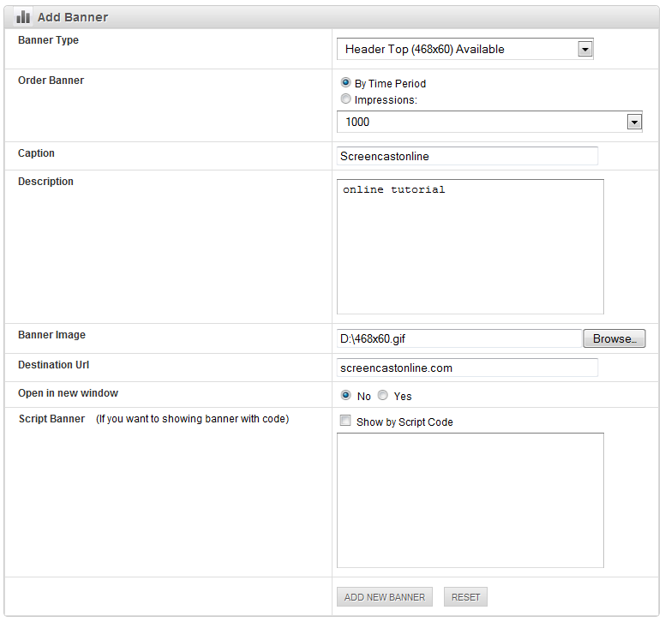

# Place a new plugin hook for banner type in indexu template file

Now you need to put the plugin hook code into indexu template. Click **Manage Banner Type**.

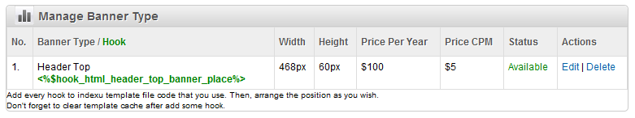

According above screenshot, you need to put the following code:

<%$hook_html_header_top_banner_place%>

Which template file need to be added above code? It depend on template do you use. If you use komet template, then it should be in header.html file. The banner location will be between logo and search box. Put the hook code there. If necessary add some html tags to keep the layout good.

I put the following code in line 53-55 after --> tag.

<div id="topbanner">

<%$hook_html_header_top_banner_place%>

</div>

Also I fixed the css file, style.css line 66

#search_box {

float:right;

margin:25px 0 0;

width:200px;

}

Here is as a result.



Github page:   
https://github.com/dodyrw/indexu-doc